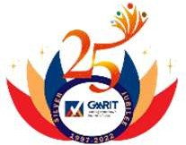 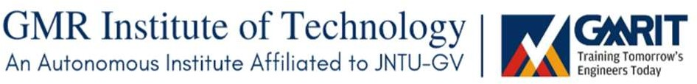 

# GMR INSTITUTE OF TECHNOLOGY, RAJAM

(An Autonomous Institution, Accredited by NBA of AICTE, NAAC of UGC & an ISO 9001:2015 Institution)

# STEPCONE 2023

EVENT WISE BUDGET LIST

|  |  |  |  |  |  |  |  |  |  |  |  |
| --- | --- | --- | --- | --- | --- | --- | --- | --- | --- | --- | --- |
| **Department of: CIVIL ENGINEERING** | | | | | | | | | | |  |
| **Faculty SPOC Nominated: Mr. BIMALENDU DASH (Asst Professor – Dept of Civil Engineering)** | | | | | | | **Mobile: 8249034185** | |  |  |  |
| **S.NO** | **TENTATIVE EVENT** | **REGN. FEE** | **EXPECTED REGISTRATI ONS** | **AMOUNT**  **FROM REGISTRATIONS** | **OTHER COSTS** | | **PRIZE MONEY** | | | **TOTAL AMOUNT** | **BUDGET EXPECTED** |
| **ITEMS** | **PRICE** | **1ST** | **2ND** | **3RD** |
| 1 | **HYDRAULIC**  **PROPULSION** | ₹4000/- | 20 TEAMS  (5 PER TEAM) | ₹80,000/- | POOL | ₹50,000/- | ₹40,000/- | ₹25,000/- | NA | ₹1,95,000/- | **₹35,000/- Required** |
|  |  |
| 2 | **ANVESHANA** | ₹500/- | 50 TEAMS  (4 PER TEAM) | ₹25,000/- | Construction materials | ₹25,000/- | ₹3000/- | ₹2000/- | NA | ₹31,000/- | **₹5,000/- Required** |
| 3 | **CADD CRACKERS** | ₹1000/- | 25 TEAMS  (2 PER TEAM) | ₹25,000/- | Snacks | ₹3000/- | ₹10,000/- | ₹6,000/- | ₹4000/- | ₹23,000/- | ₹2000/- |
| 4 | **SQUID GAMES** | ₹400/- | 40 TEAMS  (4 PER TEAM) | ₹16,000/- | Stalls | ₹16,000/- | NA | NA | NA | ₹16,000/- | NA |
| TOTAL | | ₹5,900/- |  | ₹1,46,000/- |  | ₹94,000/- | ₹90,000/- | | | ₹2,65,000/- - | **₹38,000/-** |
| **ALUMINI INTERACTION** | | **√ YES** | **/ NO** |  |  |  |  | | |  |  |

**Tentative Event:**

**HYDRAULIC PROPULSION**

**Student Co-Ordinator’s**:

PRASANNA SAI.N(20341A0191)

P. BILGATES (20341A0185)

**Target Audience:**

All branches

**Description:**

# It is an event where we used **“HYDRAULIC PROPULSION”** mechanism for boat making. Here the participants have to make their own RC boats. For the boat making there is a workshop conducted by the student coordinators through online mode. In the first round the boats have to attack each other during event. All the event is scheduled in water, for boat making the required materials are, wi-fi Module, motors, cables for connections and Batteries, propellers, push rods, couplers etc. This event has two rounds, with rules and regulations. All teams have to follow the rules if not the team will be disqualified.

# =========================================================================

# **Tentative Event: ANVESHANA**

# **Student Co-Ordinator’s:**

# P. VENKATA RATNAM (20341A0181)

# P. GEETHIKA (20341A0189)

# **Target Audience:** All branches

# **Description:**

**ANVESHANA**, it is the event where the participants have to find the required treasure. At the beginning of the event we will provide the first clue with the puzzle. When the countdown starts the participants have to solve the puzzle and they have to submit it .After that they'll start searching for the required items .With respect to the first clue they have to find the another clue. For every clue there is a material sticked with it, they have to collect all the clues including materials. And the clue includes technical questions regarding all departments. After collecting all materials, the participants have to construct the given target structure. The teams which completes with in short time, based on that the first and second will be announced as winners and runners.

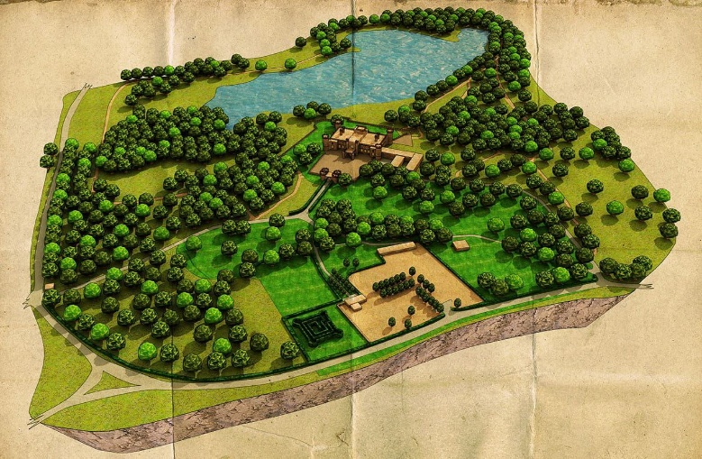 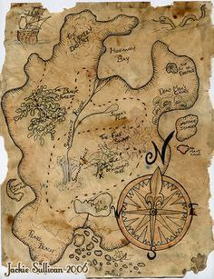

**Tentative Event: CADD CRACKERS**

**Student Co-Ordinator’s:**

K. DIVAKAR (21345A0108)

R. MOHAN KUMAR (21345A0114)

**Audience:** Civil, Mech

**Description:**

We are conducting **"CAD CRACKER"** Event. In this event the participants need to follow our guidelines. We will provide certain area, in that area the participants need to draw a plan for two or three stories Building by using AutoCAD. After that they need to Design a 3D modelling to the draw plan by using SketchUp. Major Target audience are civil engineering and mechanical engineering. The other branches may also participate. We will give participate certificate and prize for both WINNERS and RUNNERS.

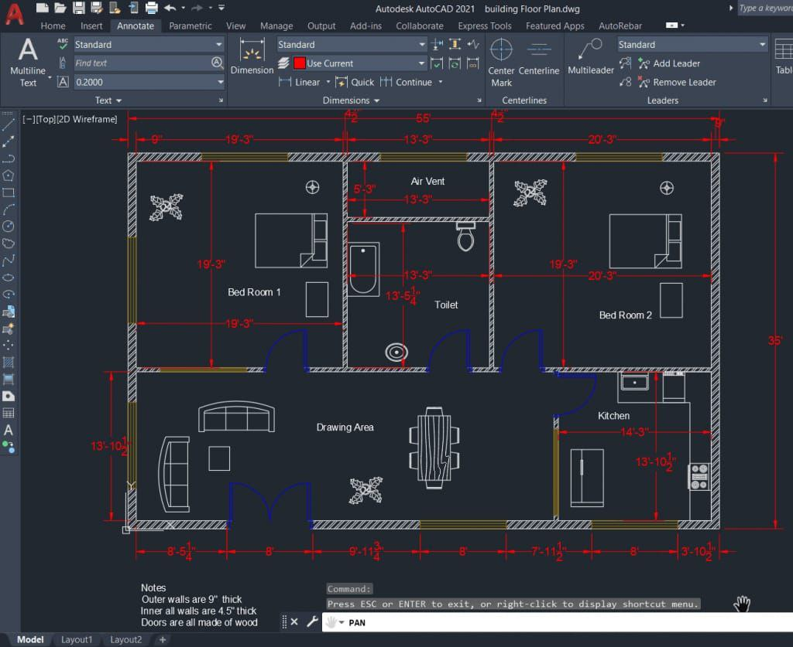 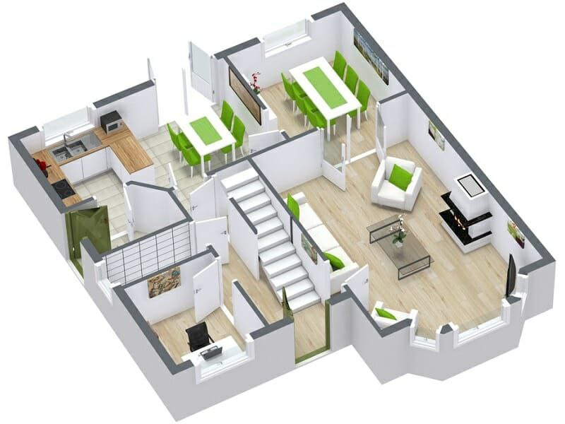

======================================================================================================

**Tentative Event: SQUID GAMES**

**Student Co-Ordinator’s:**

B. VINAY KOWSHIK (20341A0114)

B. VAMSI (20341A0108)

G. GEETHIKA MAHALAKSHMI (20341A0130)

L.N. SHRIYA (20341A0159)

**Target Audience:**

All branches

**Description:**

**“SQUID GAMES”**- It was kind of a mini gaming zone. We charged each team(2-members) a fixed entry fee (Rs 200) & every registered team got 1500 virtual bucks in return. Those bucks could spend to play both technical games like card castle, spin and win, mad math's etc., and non-technical games like balloon shooting, dancing chairs, Funtastic etc.,

Each game will have entry fee like 200 (or) 300 virtual bucks. So, for eg,10 teams of total of 3000 bucks will be collected & we give 2500 bucks to

the winning team.

So, participants keep on playing more & more to earn those virtual bucks. Each team can play any game based on their willing.

At the end of the event session, teams which are having a greater number of bucks will be awarded as winners and runners.

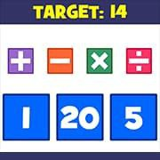 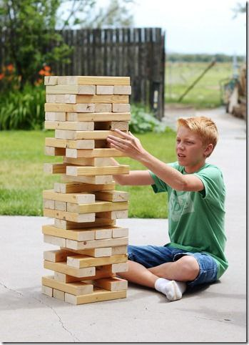

=====================================================================================

**Tentative Event: PRAYOGA**

**Student Co-Ordinator’s:**

K. MANOJ (20341A0155)

M.HEMANTH (21345A0111)

**Target Audience:**  CIVIL

**Description:**

In this **“PRAYOGA”** context the student will come up with their own prepared prototype according to the theme what we give. Civil students they have to prepare the buildings by using the mini construction materials, like that according to the branch they have to prepare a prototype and that must reflects the department of the participant.

====================================================================================================================

**Tentative Event: DATA SCIENCE APPLICATIONS USING CIVIL ENGINEERING**

**Student Co-Ordinator’s:**

P. PREM CHAND (20341A0187)

R. SHREYA (20341A0197)

**Target Audience:** All branches

**Description:**

This workshop is about the how we use data science applications in Civil stream (AIML).

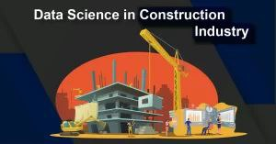 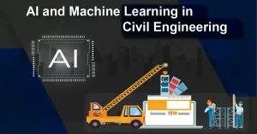

**Tentative Event: ANY TECHNICAL TOPIC**

**Student Co-Ordinator’s:**

T. SATHISH (20341A01B0)

D. MANASA (20341A0122)

**Target Audience:**

All branches

**Description:**

It is a technical event in which the participants present the paper on the topic of their own topics, they have to make sure that whatever words are used in that paper is very attractive and usage of any unparliamentary words in that paper are restricted and it should be technical. We will provide the participation certificate and will be awarded with cash prize to Winners as well as Runners.

==========================================================================================================